# Table content

1. **Project Goal**
2. **Project Objectives**
3. **Project Scope**

* **Project in Scope**
* **Target Language Platform**
* **Target Audience**
* **Out of Scope**

1. **Project Deliverable**

* **Analysis Document**
* **Design Documents**
* **User Documentation**
* **Quality Plan**
* **Project Executive**

1. **Resources**
2. **Project Milestone**
3. **Project Schedule**

# Project Proposal

# Project Introduction and Overview

Motive is to create a website for a client to store all the employee’s data for the company. The website should allow the owner to change any credentials of company employee’s data. Details of the client are given below: -

|  |  |
| --- | --- |
| **NAME** | JOHN |
| **CONTACT** | 02015136369 |
| **ADDRESS** | 7 A MERI STREET AUCKLAND |
| **E-MAIL** | john@gmail.com |

# Project Description

## Project Need

* Need the employee’s photo with details.
* Can update, edit or delete employee’s data any time
* An online functioning website can be accessible from anywhere.

## Goals and Objectives

The goal of this website is to store the data of the employee’s working in a company. The website allows the person to store the data of the employee with all their centennials and with their photo as well.

The website allows following features: -

* Can add the picture of the employee along his/her details.
* Allows to edit, update and delete the record of the employee.
* Can have the access to the salary of the employee.

## Languages used: -

* .Net framework
* C Sharp
* ASP.net
* Bootstrap
* MYSQL

## Target Audience

In the first pilot software, the target audience is: -

* Client: - Will create the data of the of the employee’s and able to do any changes like add photo and edit, update and will also be able to delete the employee who has left the company. Client will also be able to put the record of the salary of the employee.

## Out of Scope: -

* Can put the search bar to make it easy to find the specific employee
* Can put the filter functionality.

## Project Deliverable: -

## Analysis Document: -

**Wireframe of About**

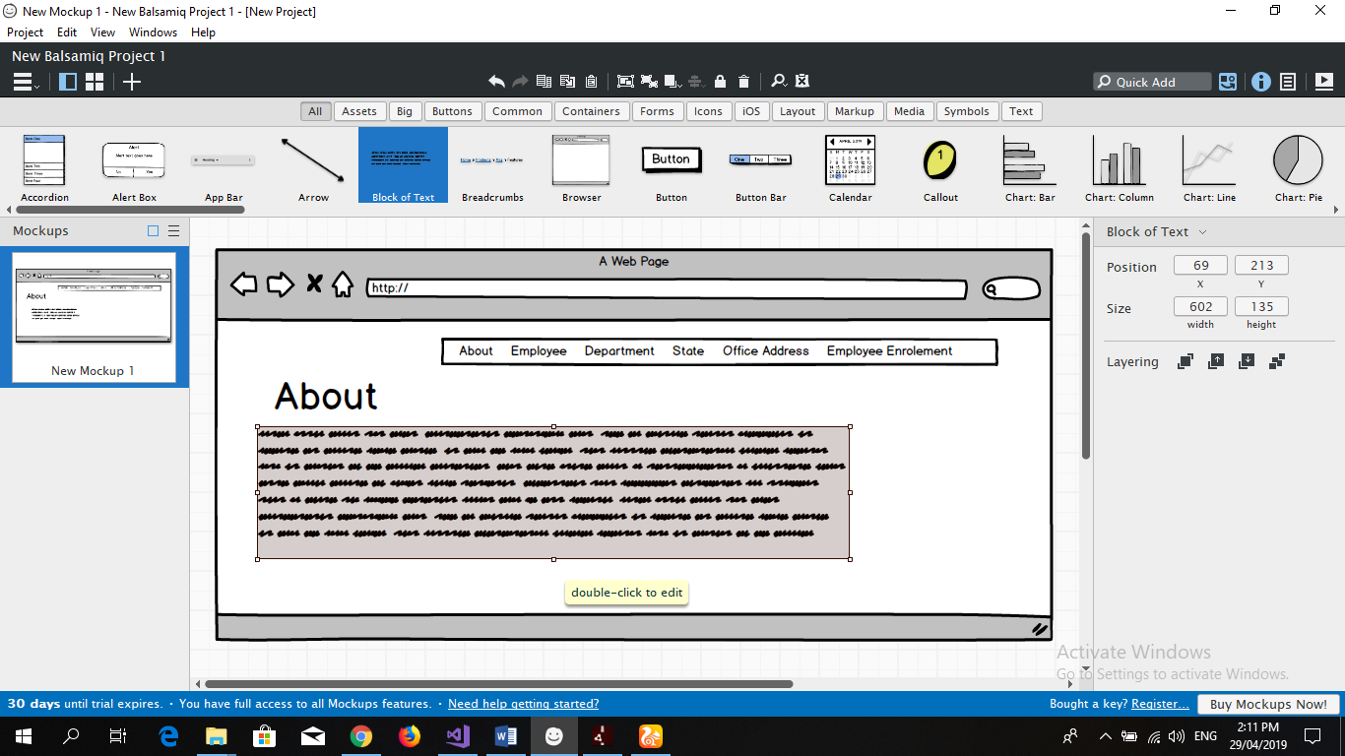

**Wireframe of Employee**

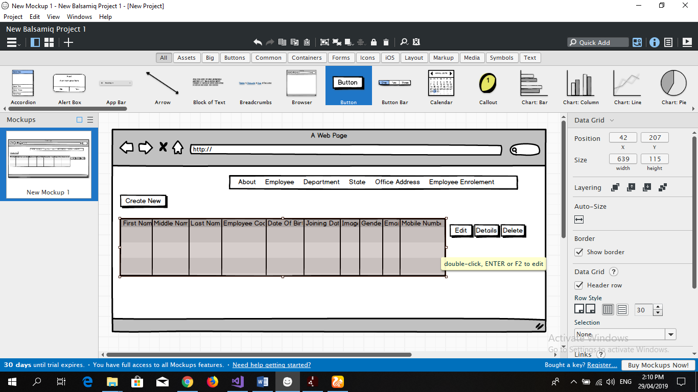

**Wireframe of Department**

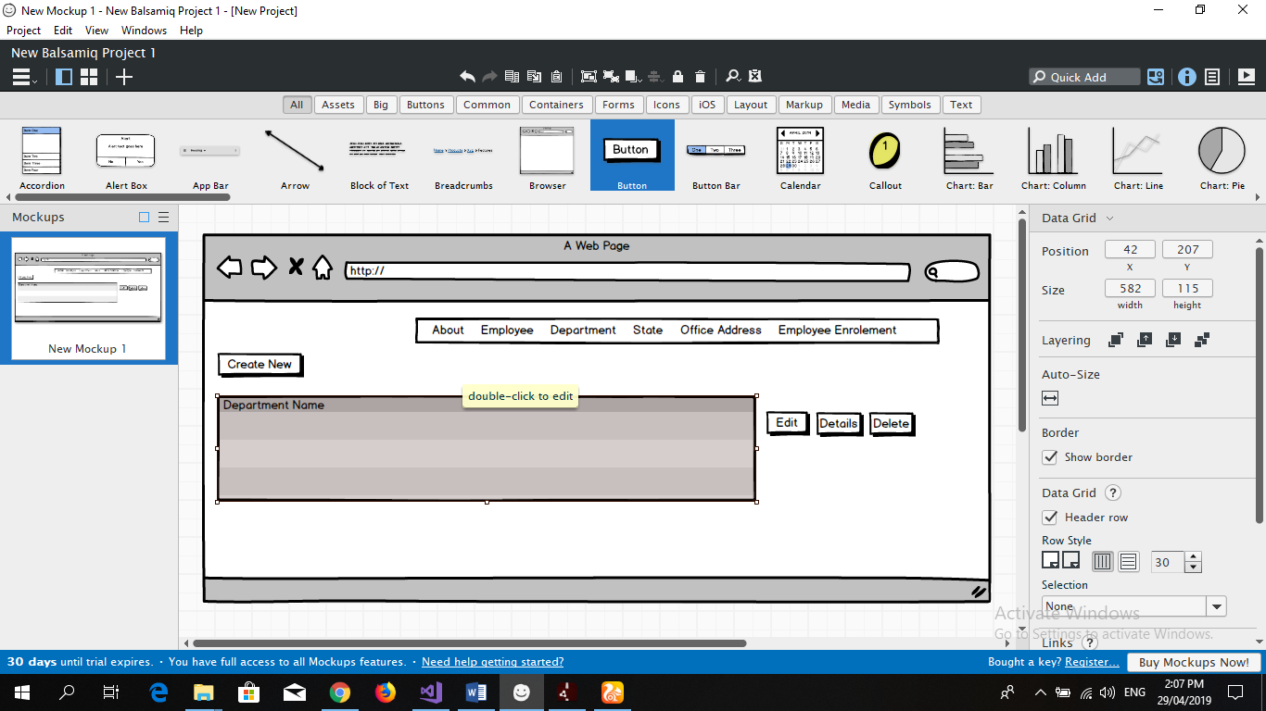

**Wireframe of State**

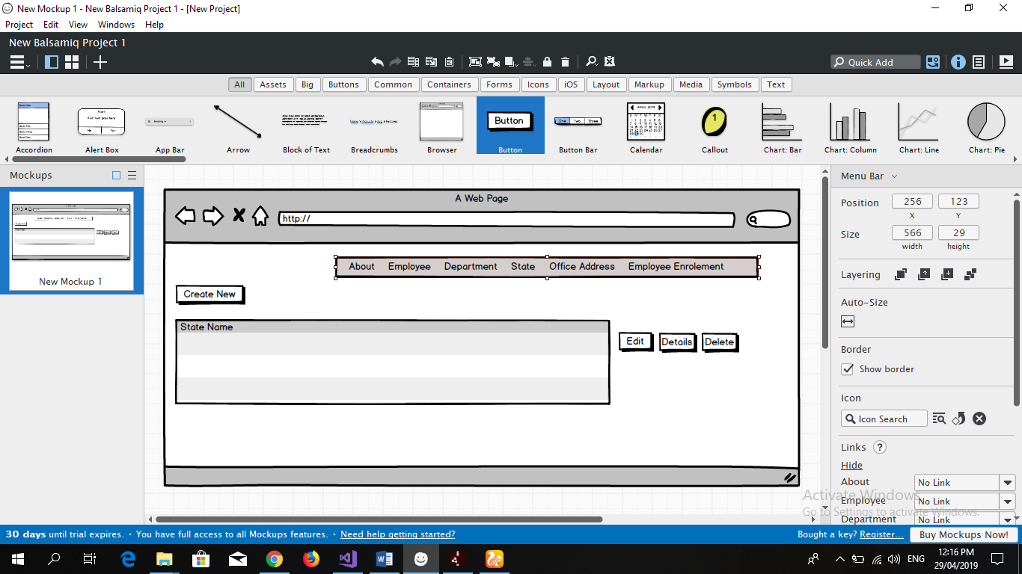

**Wireframe of office Address**

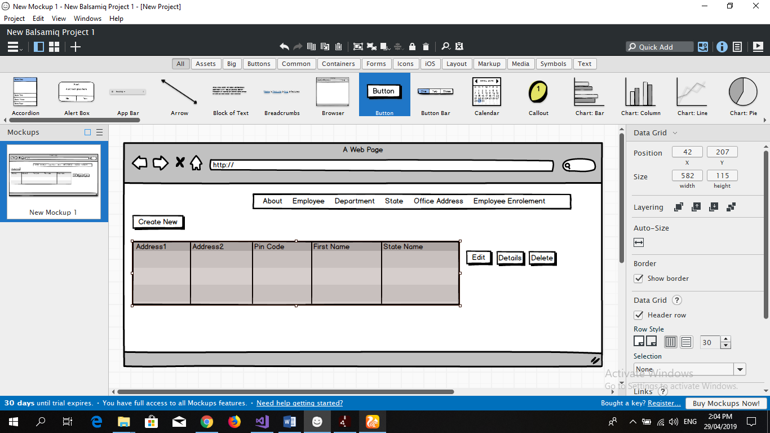

**Wireframe of Employee Enrolment**

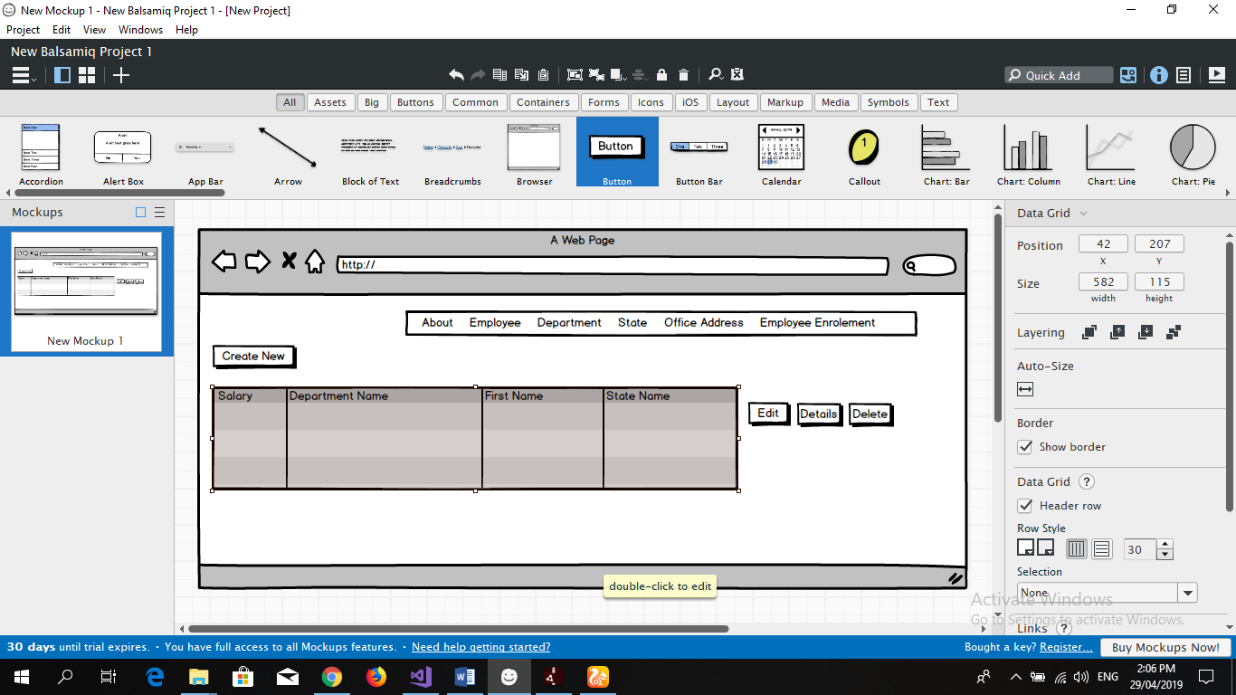

## Design Document: -

**Below are the mock-ups of given project**

**Mock-up of about page**

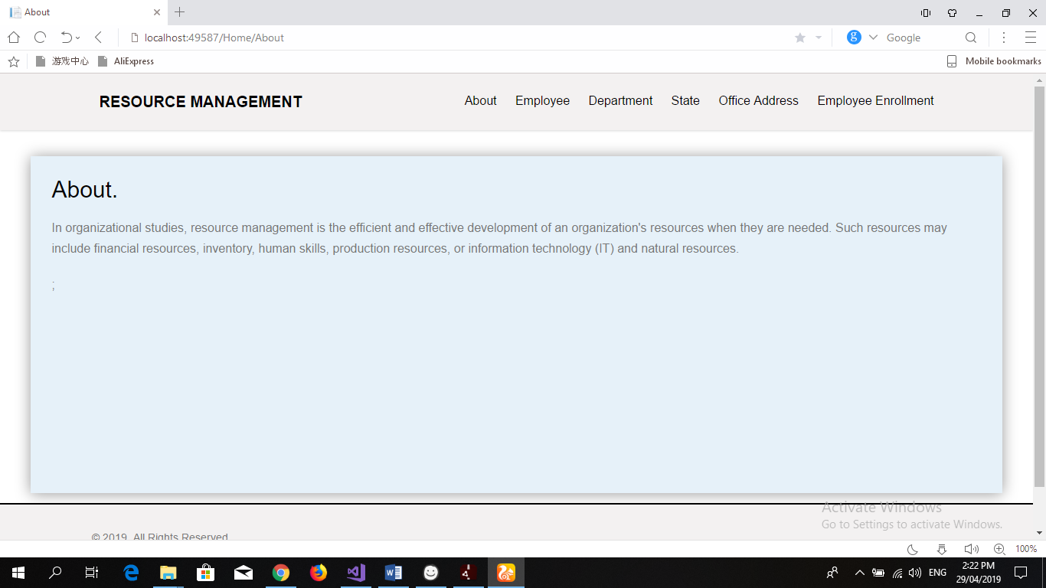

**Mock-up of Employee**

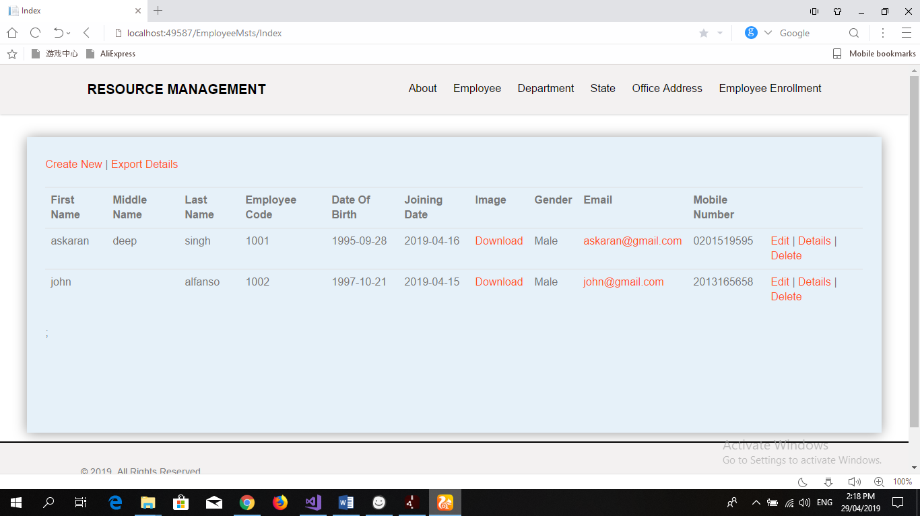

**Mock-up of Department Page**

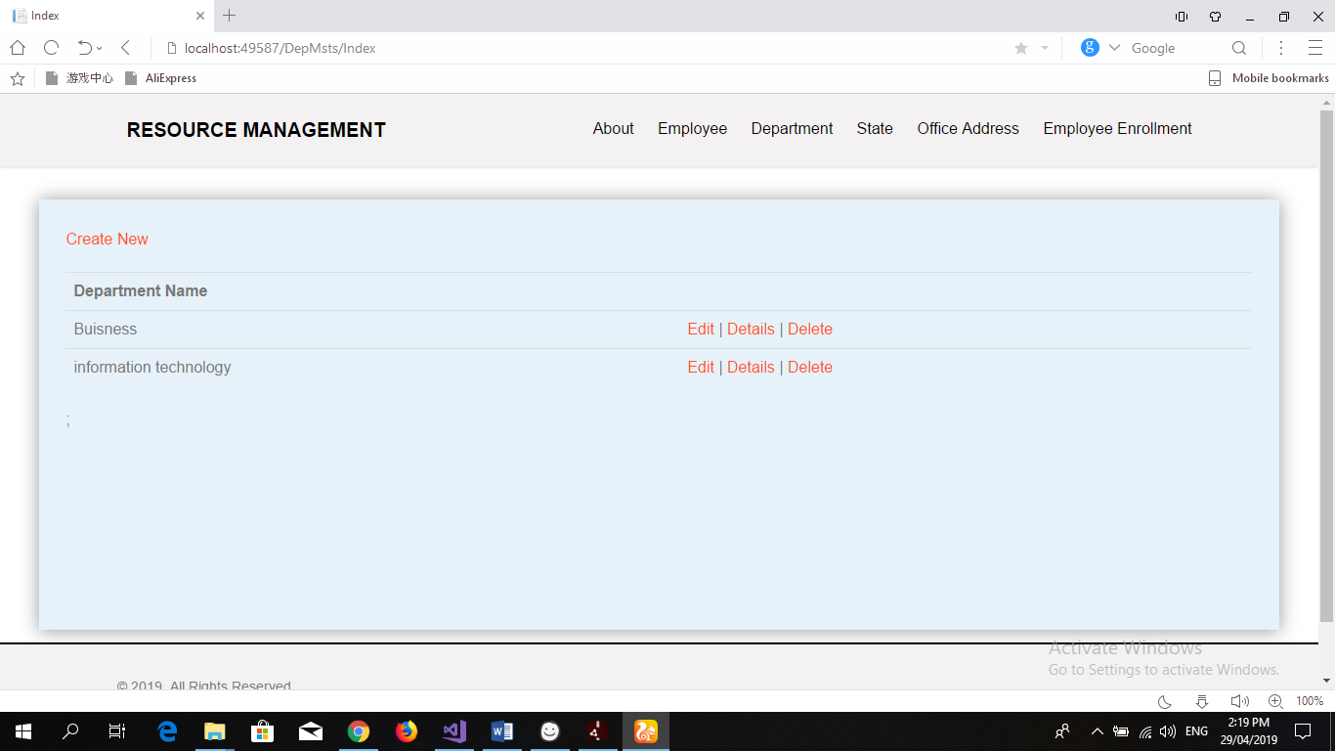

**Mock-up of State Page**

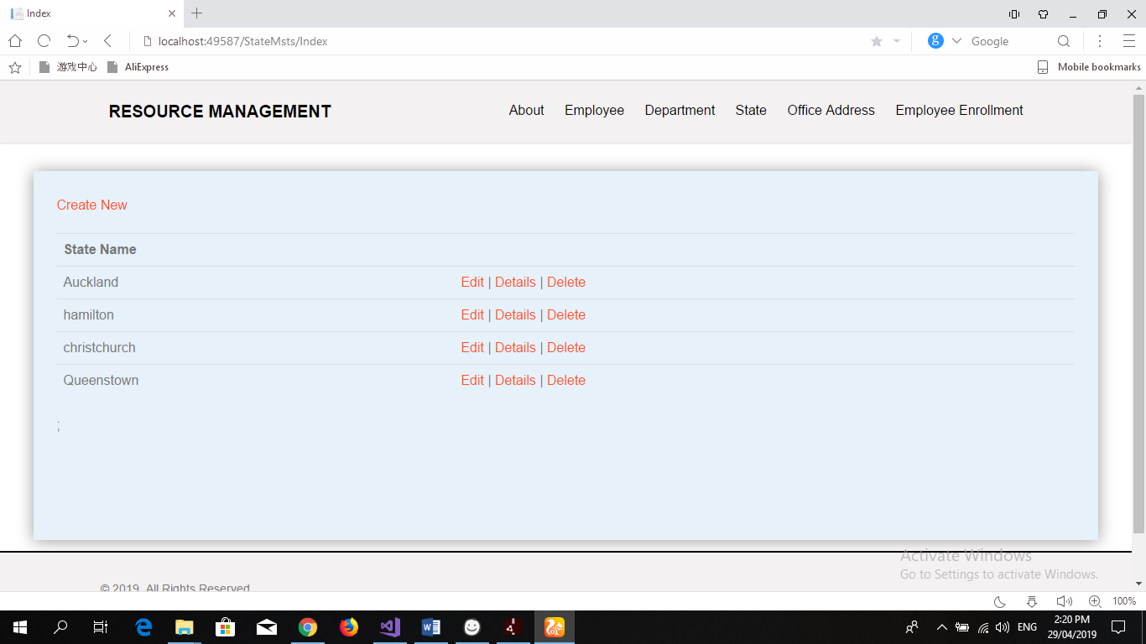

**Mock-up of Office Address Page**

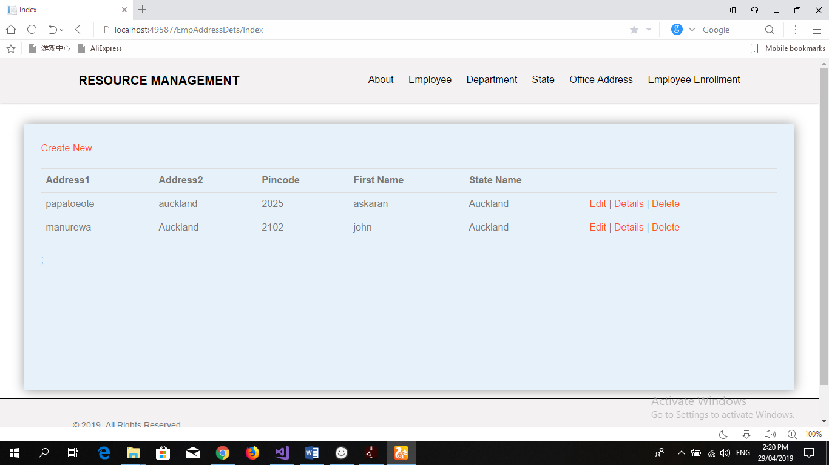

**Mock-up of Employee Enrolment Page**

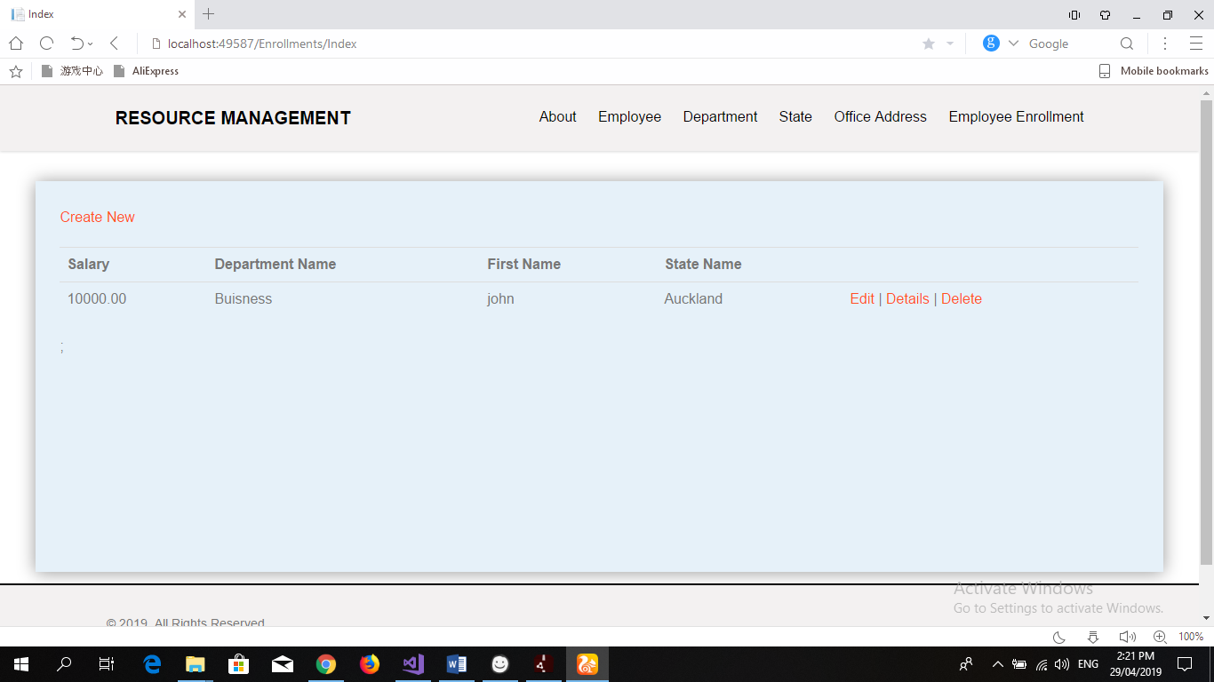

## User Documentation: -

**About Page:**

About Page is just the general information about the website and the explanation of the use of the website. About page have all the buttons at the top bar menu and the button are fully functional.

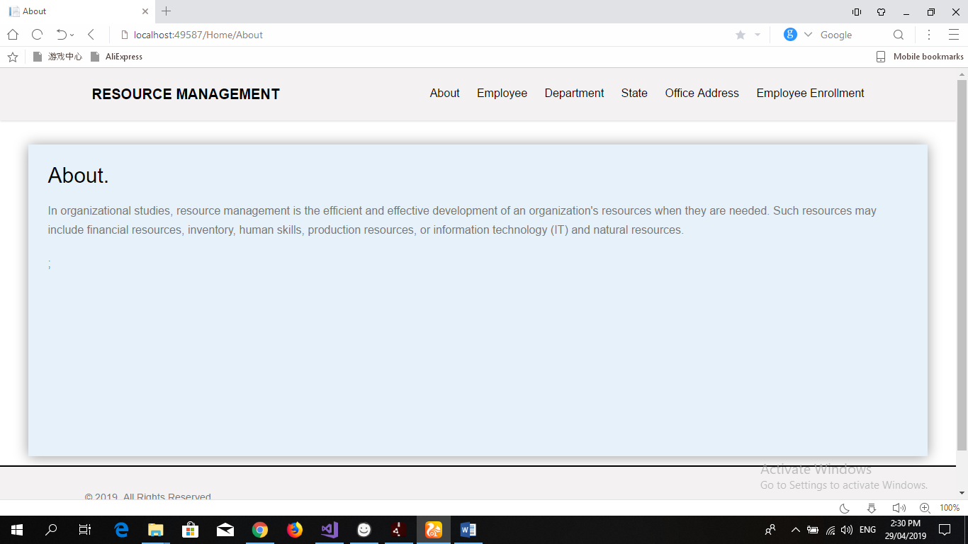

**Employee Page:**

When click on employee button a new page appears on the screen having many functionating button inside the page. At first there is a create button and export details button. Create button helps to create a new data and export details button helps to export the data from website to the local pc. When person creates the data Three more buttons appears at the end of the data line which are Edit, Details and Delete button and each button performs its own function. Edit button helps to edit the information of the following employee. Details button gives all the details of the employee present in the system and Delete button helps to delete any extra information of any employee or any extra employee. Below is the screenshot:

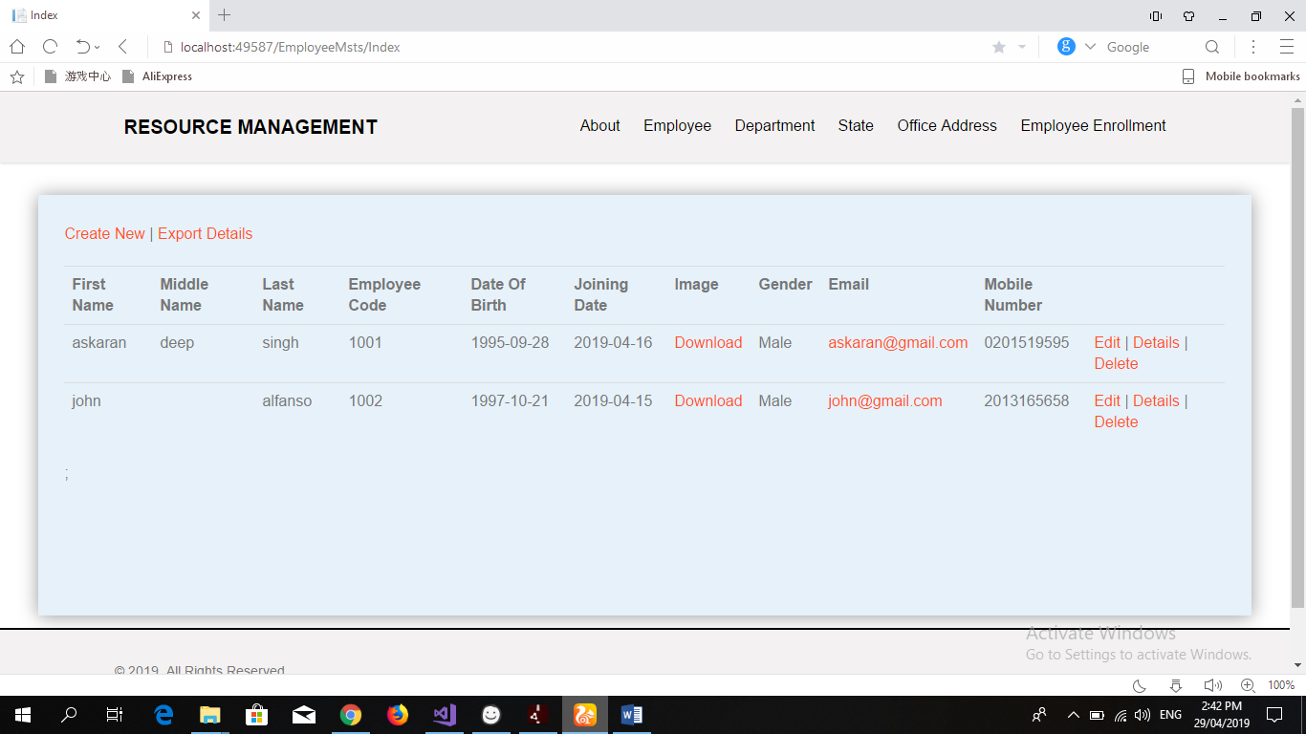

**Department Page:**

When clicking on Department button a new page appears. Department is all about the different departments that company is offering. Below the menu bar there is a create button which helps the user to create different departments that the company is holding. Once you enter the department three more buttons appears at the end at the end of the data those are Edit, Details and Delete button. There three button performs the same function as explained in the above para but this time the details which are going to be edited are related to the department page.

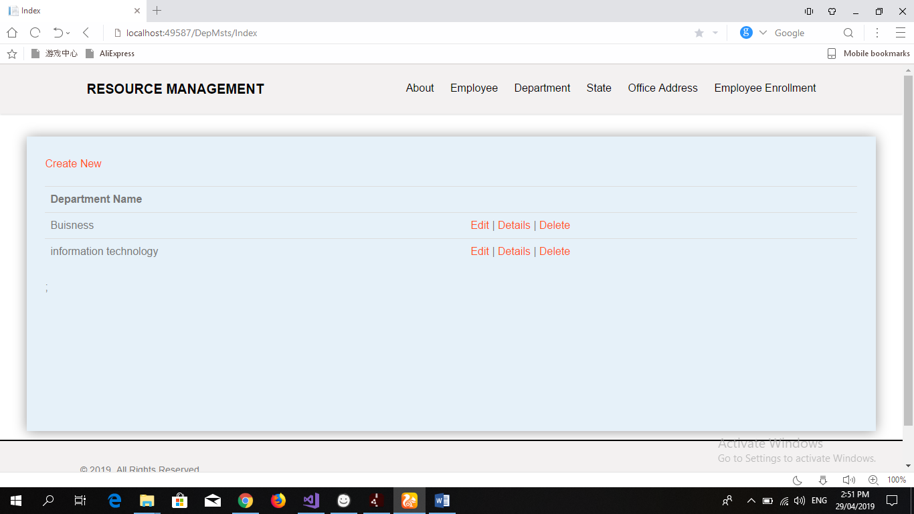

**State Page:**

At the starting of the state page same menu bar appears that used to appears on the on the other pages. Again, there is the create button below the menu bar and again the create button helps to create the data of different names of the different states so that the boss can find out that which employee belongs to which state. Below is the screenshot:

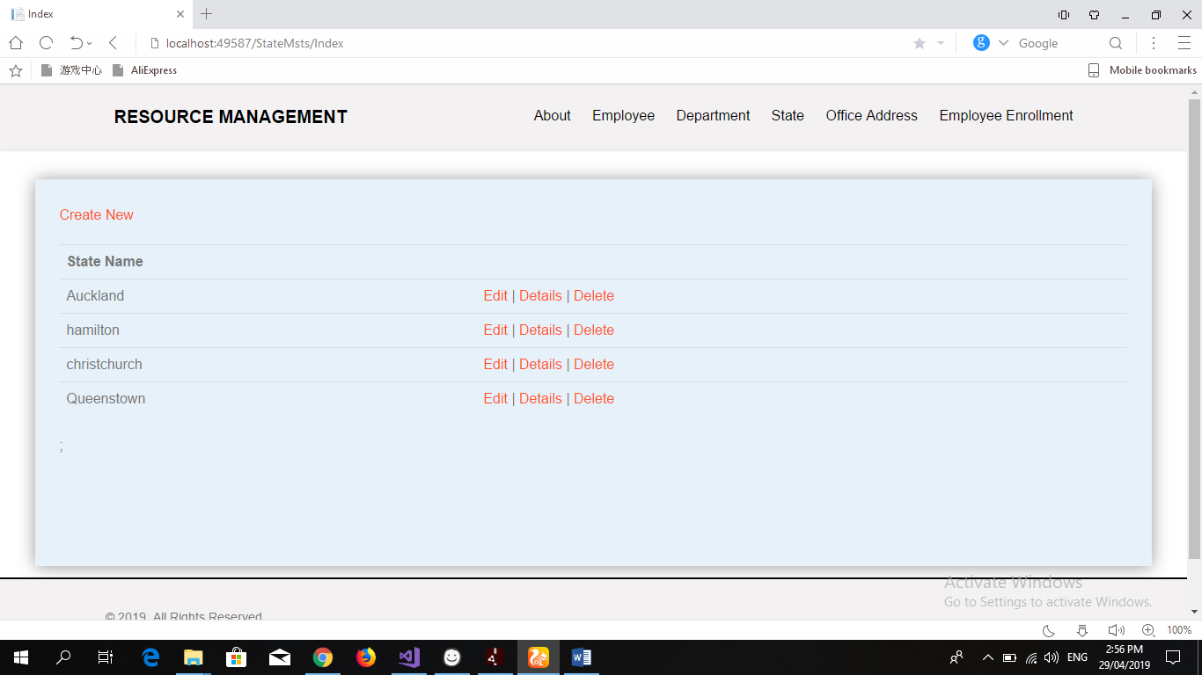

**Office Address Page:**

Office address helps to record the all the address of the employees working in the company. Again, create button will appear below the menu bar. create button helps to create the data of the permanent address of every employee working in the company. Below is the screenshot:

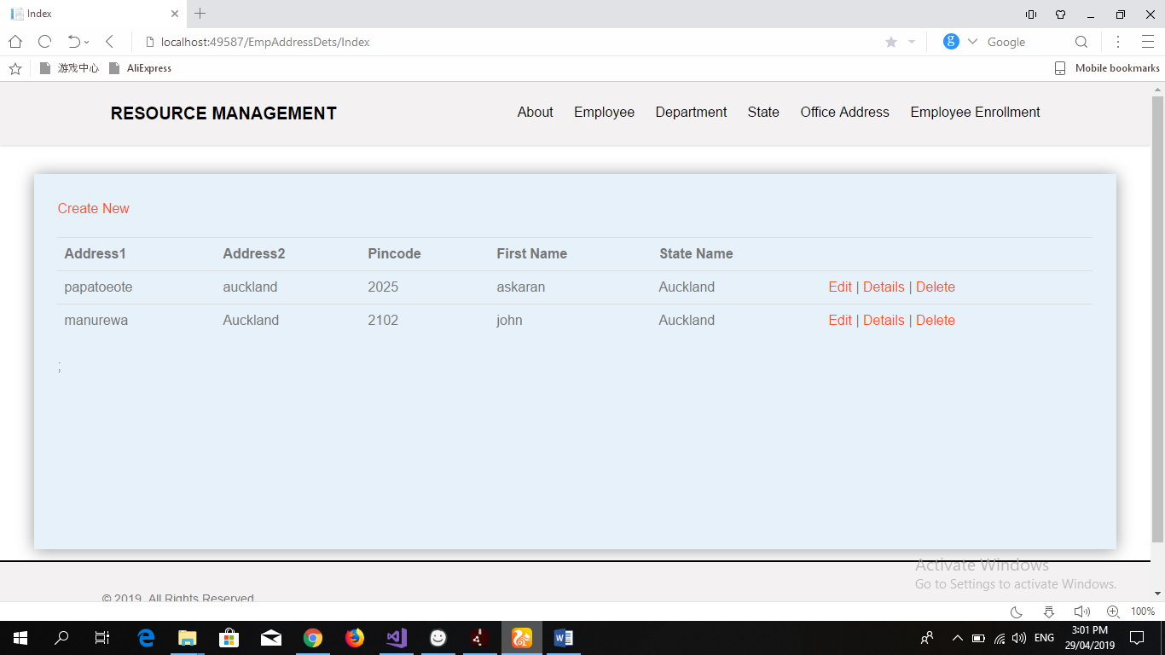

**Employee Enrolment Page:**

Employee Enrolment page holds the data like salary of the employee the department name, first name and the state name from which the employee belongs. Same like other pages this page also has the create button below the menu bar and after creating the data three more buttons appears which are Edit, Details and Delete button having same function unlike other pages but performing the functions for the resulting page. Below is the screenshot:

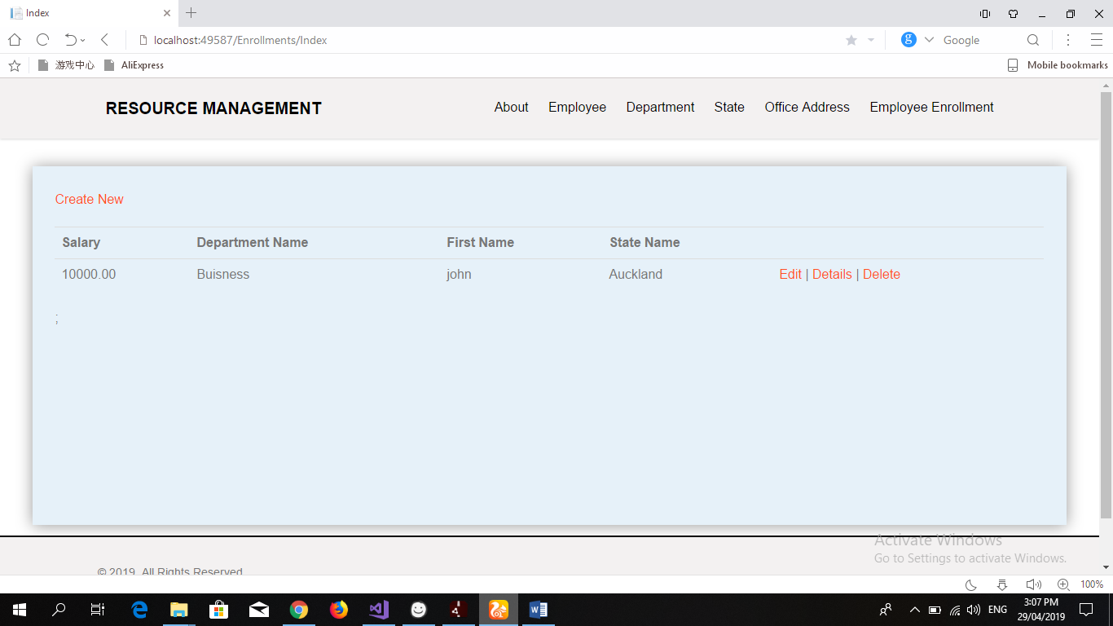

## Quality Plan: -

|  |  |  |  |  |  |
| --- | --- | --- | --- | --- | --- |
| Step NO | Test Step | Input Data | Expected Result | Actual Result | Test Step Result |
| 1 | Create New Employee | John | All Details Should Appear on The Screen | As Expected | Pass |
| 2 | Edit Button OF Department | John | Changes in information should be accepted | As Expected | Pass |
| 3 | Details Button in State Page | Auckland | Details About the State when created should be appear | As Expected | Pass |
| 4 | Delete Button in all pages | John | All the Details should be deleted From the System | As Expected | Pass |
| 5 | Download Button in Employee page | John | Image Should be downloaded in the system | As Expected | Pass |

## Project executive summary: -

**Hardware: -**

* Windows 10
* Intel core processor i5
* 8GB RAM

**Software: -**

* Visual Studio 2017
* Microsoft SQL

**Languages: -**

* C Sharp
* jQuery
* ASP.Net
* SQL

## Resources: -

Requirements Required to complete this project are as follow:

* PC must have RAM of 8GB.
* Windows used should be Windows 10.
* At least Intel i5 Processor should be used.
* Visual Studio 2017 is Required for the coding.
* Microsoft SQL is required for establishing the database and for the connection between visual studio and database.
* C#, jQuery, bootstrap, HTML, NETFramwork, ASP, all of them should be used.

## Project Milestone: -

|  |  |
| --- | --- |
| **WORK** | **DAY** |
| Database | 10 April to 12 April |
| Controller | 13 April to 18 April |
| Front End | 19 April to 23 April |
| Back End Coding | 24 April to 28 April |
| Documentation | 28 April to 30 April |

## Project Schedule: -

|  |  |
| --- | --- |
| **WORK** | **HOURS** |
| **Database** | **5 hours** |
| **Controller** | **10 hours** |
| **Front End** | **10 hours** |
| **Back End Coding** | **16 hours** |
| **Documentation** | **3 hours** |